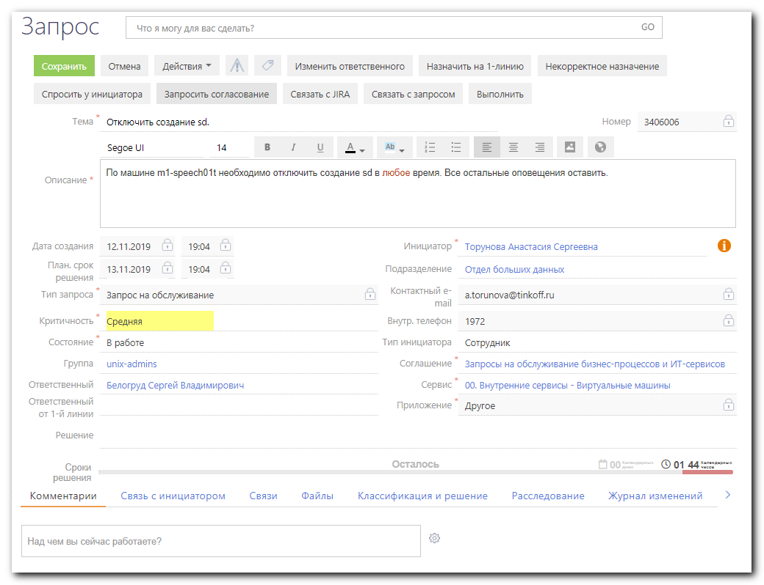

#
# Same shit, only for windows hosts.
#

[root@vm-vol-nag4-tst objects]# vim servers/dc-vd/vd-dhcp01p.cfg
define host{
use windows-server
host_name vd-dhcp01p
hostgroups windows-servers
contact_groups windows-admins-wo-sd
contacts m.kubrak_sms,n.derkaev_sms,servicedesk_duty_khutor_sms,servicedesk_duty_sms,n.ekimov_sms,m.kubrak_email,n.derkaev_email,n.ekimov_email
address 172.17.64.41
}
...

#
# Here are changes.

cat servers/dc-m1/linux/m1-speech01t.cfg
...
define host{
use linux-server
host_name m1-speech01t
address 10.216.51.3
notes_url https://wiki.tcsbank.ru/display/sd/$HOSTNAME$
contact_groups linux-admins-wo-sd
}
…
define service{
use generic-service-ntp
host_name m1-speech01t
service_description NTP
service_groups Clock offset - Service Group
contacts empty_contact
contact_groups linux-admins-wo-sd
check_command check_nrpe!check_ntp_time
}
...

[root@vm-vol-nag4-tst objects]# cat /tmp/20191113-1231.sh service_name="Current Memory Load"

while read var1_hostname
do
echo
echo -e "${var1_hostname}"
echo -e "\t${service_name}"
pynag update set notification_options="u,c,r" where object_type=host and host_name="${var1_hostname}" and object_type=service and service_description="${service_name}" --force
# pynag update set notes_url="https://wiki.tcsbank.ru/pages/viewpage.action?pageId=299629945" where object_type=host and host_name="${var1_hostname}" and object_type=service and service_description__$ontains="${service_name}" --force
done << 'EOF'
ds-sage-eshot-prod01
ds-sage-eshot-prod02
ds-sage-esmas-prod01
ds-sage-esmas-prod02
ds-sage-esmas-prod03
ds-sage-eswarm-prod01
ds-sage-eswarm-prod02
ds-sage-ingest-prod01
ds-sage-ingest-prod02
ds-sage-soc-prod01
ds-sage-soc-prod02
ds-sage-soc-prod03
ds-sage-soc-prod04
ds-sage-soc-prod05
ds-sage-soc-prod06
EOF
[root@vm-vol-nag4-tst objects]#

[root@vm-vol-nag4-tst objects]# vim templates/hosts-templates.cfg
define host{
name generic-host
...
contact_groups servicedesk-duty-critical-group
...
define host{
name linux-server
use generic-host
contact_groups linux-admins, servicedesk-duty-critical-group
hostgroups linux-servers
icon_image linux.png
statusmap_image linux.gd2
register 0
}
...

[root@vm-vol-nag4-tst objects]# cat groups/contact-group/linux-admins.cfg
...
define contactgroup{
contactgroup_name linux-admins-nosd
alias Linux Administrators no sd
members a.terentyev_sms, a.terentyev_email, a.aleksandrov_email, a.aleksandrov_sms, s.belogrud_email, s.belogrud_sms, a.chernyh_email, a.chernyh_sms, a.leonov_email, servicedesk_duty_$
hutor_sms_critical, servicedesk_duty_sms_critical, i.komyagin_email, i.komyagin_slack, p.selin_email, k.kurbanov_email
}
...
# SD2510011
define contactgroup{
contactgroup_name linux-admins-wo-sd
alias Linux Administrators without auto create tasks in service desk
members a.terentyev_sms, a.terentyev_email, a.aleksandrov_email, a.aleksandrov_sms, n.makhnev_email, n.makhnev_sms, s.belogrud_email, s.belogrud_sms, a.chernyh_email, a.chernyh_sms, a$leonov_email, servicedesk_duty_khutor_sms_critical, servicedesk_duty_sms_critical,i.komyagin_email, i.komyagin_slack, p.selin_email, k.kurbanov_email, k.kurbanov_sms
}
...

[root@vm-vol-nag4-tst objects]# cat groups/contact-group/servicedesk-duty-group.cfg
define contactgroup{
contactgroup_name servicedesk-duty-critical-group
alias ServiceDesk Duty
members servicedesk_duty_sms_FOR_DUTY_GROUP, servicedesk_duty_khutor_sms_FOR_DUTY_GROUP, servicedesk_duty_diapazon1_sms_FOR_DUTY_GROUP, servicedesk_duty_diapazon2_sms_FOR_DUTY_GROUP, servicedesk_duty_diapazon3_sms_FOR_DUTY_GROUP, mrrobot_email
}
[root@vm-vol-nag4-tst objects]#

[root@vm-vol-nag4-tst objects]# egrep -irle "servicedesk_duty_sms_FOR_DUTY_GROUP|servicedesk_duty_khutor_sms_FOR_DUTY_GROUP|servicedesk_duty_diapazon1_sms_FOR_DUTY_GROUP|servicedesk_duty_diapazon2_sms_FOR_DUTY_GROUP|servicedesk_duty_diapazon3_sms_FOR_DUTY_GROUP|mrrobot_email" contacts/
contacts/mrrobot.cfg
contacts/servicedesk_duty.cfg
[root@vm-vol-nag4-tst objects]#

[root@vm-vol-nag4-tst objects]# cat contacts/mrrobot.cfg
define contact{
use generic-contact
contact_name mrrobot_email
alias Andrey Kuritcyn MR.Robot
email mr.robot@tinkoff.ru
}
[root@vm-vol-nag4-tst objects]#

[root@vm-vol-nag4-tst objects]# egrep -A 3 -ire "servicedesk_duty_sms_FOR_DUTY_GROUP|servicedesk_duty_khutor_sms_FOR_DUTY_GROUP|servicedesk_duty_diapazon1_sms_FOR_DUTY_GROUP|servicedesk_duty_diapazon2_sms_FOR_DUTY_GROUP|servicedesk_duty_diapazon3_sms_FOR_DUTY_GROUP|mrrobot_email" contacts/servicedesk_duty.cfg | egrep -e "contact_name|address1|--"
contact_name servicedesk_duty_sms_FOR_DUTY_GROUP
address1 79858577693
--
contact_name servicedesk_duty_diapazon1_sms_FOR_DUTY_GROUP
address1 79036698280
--
contact_name servicedesk_duty_diapazon2_sms_FOR_DUTY_GROUP
address1 79036698249
--
contact_name servicedesk_duty_diapazon3_sms_FOR_DUTY_GROUP
address1 79036698253
--
contact_name servicedesk_duty_khutor_sms_FOR_DUTY_GROUP
address1 79250109634
[root@vm-vol-nag4-tst objects]#

